AIRPORT FLIGHT BOARD & SCHEDULER

ABSTRACT

The Airport Flight Board and Scheduler is a simple Java-based project used to manage and display flight information. It shows details such as the flight number, airline name, destination, departure time, gate number, and flight status.

The system helps passengers and airport staff easily check flight details and schedules. It can also be used to update flight information when there are changes in the schedule or flight status.

The main purpose of this project is to make flight information easy to manage, update, and view. This project also helps us understand important Java concepts such as classes, objects, methods, arrays or collections .

ADVANTAGES

Easy Flight Management – Helps manage flight details in an organized way.

Quick Access to Information – Users can easily view flight number, airline, destination, time, gate, and status.

Easy Schedule Updates – Flight schedules and statuses can be updated whenever needed.

Saves Time – Reduces the need to manually check and manage flight information.

Reduces Errors – Organized data entry helps reduce mistakes in flight details.

User-Friendly – The system is simple and easy for users to understand and operate.

Better Organization – Keeps all important flight information together in one system.

Useful for Airports – Can help airport staff and passengers access flight information efficiently.

DISADVANTAGES

Requires Regular Updates – Flight information must be updated whenever there is a change.

Limited Functionality – The basic system may not include advanced airport features.

Dependent on Correct Input – Incorrect information entered by the user can lead to wrong flight details.

No Real-Time Data – Without connection to live airport systems, the flight status may not update automatically.

Limited User Access – A basic Java application may not support many users at the same time.

No Online Booking – The system is mainly for displaying and managing flight information, not for booking tickets.

Requires Maintenance – The program may need changes or improvements when airport requirements change.

IMPLEMENTATION DETAILS

The Airport Flight Board and Scheduler is implemented using the Java programming language. The project is divided into three main modules:

Flight Details Module
This module stores and manages basic flight information such as flight number, airline, destination, departure time, gate number, and flight status.

Flight Scheduling Module
This module is used to add, update, and manage flight schedules. It helps maintain the correct departure time, gate, and status of each flight.

Flight Board Display Module
This module displays the available flight information in an organized and easy-to-read format. Users can view the flight details and check their current status.

The project uses Java concepts such as classes, objects, methods, conditional statements, loops, and collections. The system takes user input, processes the information, and displays the required flight details.

CODE:
import java.util.Scanner;

public class Main {

// MODULE 1: Flight Class
static class Flight {
String flightNumber;
String airline;
String destination;
String status;
// Constructor
Flight(String flightNumber, String airline,
String destination, String status) {

this.flightNumber = flightNumber;
this.airline = airline;
this.destination = destination;
this.status = status;
}
}
// MODULE 3: Method
public static void analyzeFlights(
Flight[] flights, int count) {

int scheduled = 0;
int delayed = 0;
int cancelled = 0;

// MODULE 2: Array and Loop
for (int i = 0; i < count; i++) {

if (flights[i].status.equalsIgnoreCase("Scheduled")) {
scheduled++;
}
else if (flights[i].status.equalsIgnoreCase("Delayed")) {
delayed++;
}
else if (flights[i].status.equalsIgnoreCase("Cancelled")) {
cancelled++;
}
}

System.out.println("\n--- FLIGHT REPORT ---");
System.out.println("Total Flights: " + count);
System.out.println("Scheduled: " + scheduled);
System.out.println("Delayed: " + delayed);
System.out.println("Cancelled: " + cancelled);

// MODULE 3: IF-ELSE
if (delayed > scheduled) {

System.out.println(
"Status: High flight delays."
);

}
else if (cancelled > scheduled) {

System.out.println(
"Status: Many flights are cancelled."
);

}
else {

System.out.println(
"Status: Airport operations are normal."
);
}
}

public static void main(String[] args) {

Scanner sc = new Scanner(System.in);

// MODULE 2: Array
Flight[] flights = new Flight[10];

int count = 0;
boolean running = true;

System.out.println(
"=== AIRPORT FLIGHT BOARD & SCHEDULER ==="
);

while (running) {

System.out.println("\n1. Add Flight");
System.out.println("2. View Flights");
System.out.println("3. Flight Report");
System.out.println("4. Exit");

System.out.print("Enter choice: ");

int choice = sc.nextInt();
sc.nextLine();

switch (choice) {

case 1:

if (count < flights.length) {

System.out.print("Flight Number: ");
String number = sc.nextLine();

System.out.print("Airline: ");
String airline = sc.nextLine();

System.out.print("Destination: ");
String destination = sc.nextLine();

System.out.print(
"Status (Scheduled/Delayed/Cancelled): "
);

String status = sc.nextLine();

// OBJECT CREATION
flights[count] = new Flight(
number,
airline,
destination,
status
);

count++;

System.out.println(
"Flight added successfully!"
);

}
else {

System.out.println(
"Flight limit reached!"
);
}

break;

case 2:

System.out.println(
"\n--- FLIGHT BOARD ---"
);

for (int i = 0; i < count; i++) {

System.out.println(
flights[i].flightNumber +
" | " +
flights[i].airline +
" | " +
flights[i].destination +
" | " +
flights[i].status
);
}

break;

case 3:

analyzeFlights(
flights,
count
);

break;

case 4:

running = false;

System.out.println(
"Thank you!"
);

break;

default:

System.out.println(
"Invalid choice!"
);
}

sc.close();
}
}

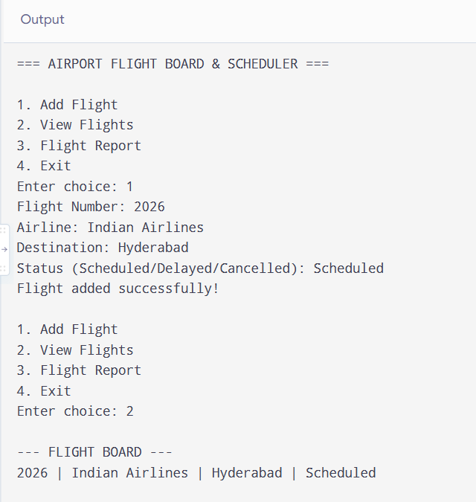
OUTPUT:
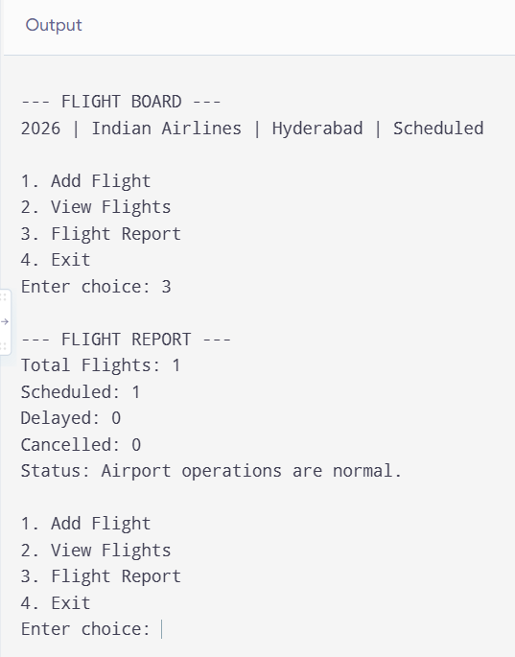

CONCLUSION

The Airport Flight Board and Scheduler provides a simple and organized way to manage and display flight information. The project is divided into three modules: Flight Details, Flight Scheduling, and Flight Board. It helps users easily view and update important flight information such as the destination, departure time, gate number, and flight status.

This project also helps in understanding important Java programming concepts such as classes, methods, variables, conditional statements, loops, and user input. Overall, the project provides a basic foundation that can be further developed into a more advanced airport management system.

FUTURE WORK

In the future, this project can be improved by adding more advanced features such as:

Real-time flight status updates

Multiple flight management

Online ticket booking

Passenger information management

Automatic notifications for delays and cancellations

Database connectivity to store flight information

A web or mobile application for easy access

